30th NATIONAL RADIO SCIENCE CONFERENCE
(NRSC 2013)
April 16‐18, 2013, National Telecommunication Institute, Egypt

Novel Wideband MIMO Antennas That Can Cover the Whole LTE Spectrum in

Handsets and Portable Computers

Mohamed Sanad

Faculty of Engineering, Cairo University, Giza, Egypt, msanad@hotmail.com

ABSTRACT

A dual resonant antenna configuration is developed for multi-standard multifunction mobile handsets and portable computers. Only two wideband resonant antennas can cover most of the LTE spectrum in portable communication equipment. The bandwidth that can be covered by each antenna exceeds 70% without using any matching or tuning circuits, with efficiencies that reach 80%. Thus, a dual configuration of them is capable of covering all LTE (4G) bands besides the existing 2G and 3G bands. 2x2 MIMO configurations have been also developed for the two wideband antennas with a maximum isolation and a minimum correlation coefficient between the primary and the diversity antennas.

Keywords: Antenna, Wideband, LTE, MIMO

I. | INTRODUCTION
 | Customers’ increasing expectations for speed, bandwidth, and global access is driving the evolution of
wireless broadband technology. Customers want more information |  | such as business, consumer applications
and | entertainment available through their mobile devices, but with | greater speeds [1]. LTE represents the next
big step towards the 4th generation (4G) of radio technologies which is expected to increase the capacity and the speed of mobile telephone networks. The lack of spectrum harmonization represents a key challenge for the emerging LTE ecosystem, potentially preventing vendors from delivering globally compatible LTE products such as devices and chipsets. Spectrum fragmentation has the potential to hinder global LTE roaming if device manufacturers are required to include support for many disparate frequencies in their devices. Yet, in fragmented regional markets such as Europe, LTE roaming is some way off as operators will be providing LTE in different bands and the devices will need to be able to seamlessly switch between the frequency bands used for LTE in addition to the 2G and 3G networks [2].

A. Conventional antenna challenges in LTE

The antenna is becoming an increasingly critical component for LTE device vendors. It is possible that future terminal devices will have more than 20 antennas to cover all the important wireless applications [3]. In addition, the industry is painfully aware of the issues that surround implementing LTE in small mobile devices with already limited space and extremely high performance expectations. Due to this trend, wideband antenna coverage is a hot issue that has to be addressed [4]. Device makers are finding it difficult to decide which bands to prioritize as chipsets and handsets are developed. The priority would be for the 800 MHz band. Most of the investment has been directed towards that band because it is the band that two-thirds of current LTE users occupy, largely driven by the US network roll outs of Verizon Wireless and AT&T [2]. This low frequency band means larger antennas in terms of size, which is a challenging issue keeping in mind the limited size of LTE devices. The urgent demand for wideband LTE coverage represents a serious challenge facing antenna designers. Adapting the conventional antenna technology to serve the wideband demand was not a much of a success; leading to a definitive belief that passive antennas have reached their limits [5]. Thus, the active tunable antenna approach has been adopted to fulfill the market need for world LTE devices, trading the passive antenna simplicity with active antenna complexity.

B. Disadvantages of active antennas and extended grounds planes

Passive antennas have various advantages over the active tunable antennas. First of all, the passive antenna does not have to be supported with RF controlling circuit to do the job as the active one, so it will save large space required inside the handset to fit both the antenna and the RF circuit. This is not the only problem of the RF circuit, as additional circuit components are connected to the antenna; it will suffer from impedance mismatch. In

30th NATIONAL RADIO SCIENCE CONFERENCE
(NRSC 2013)
April 16‐18, 2013, National Telecommunication Institute, Egypt

this situation a severe decrease in the efficiency of the antenna will lead to a lower speed of data transfer and a higher number of dropped calls. Also, the active antenna is power consuming, causing a significant decrease in the battery life time. Thus, it will be a problem for power hungry, smart handheld devices. Last but not least, the active antenna seems to have band limitations too, as the maximum number of bands that commercial LTE active antennas can support is 13 bands only out of LTE bands. On the other hand, Current handset antenna technologies are still tied with the extended ground plane’s dilemma. As the antenna is not just the module that fits under the speaker, however it includes a large PCB ground plane. A minimum limit size of the ground plane is required for the antenna to have an acceptable performance. Thus, adding an extra volume counted on the total size of the antenna. As the ground plane is a part of the antenna structure then the hand grip on the phone will cause detuning of the antenna operating frequency causing a poor efficiency.

C. A novel resonant wide band passive antenna

A novel antenna technology has been developed to solve the problem of the urgent need for universal LTE devices. The new technology can cover all the possible LTE spectrum bands using only two antennas with bandwidths of 73% and 75.8% respectively without using any matching or tuning circuits. The first antenna is covering the low band LTE spectrum starting from 698 MHz up to 960 MHz which includes LTE band numbers 5, 6, 8, 11, 12, 13, 14, 17, 18, 19, 20, 21, 24, 26, 27, 28, 29, and 44. The second one is covering the high band portion of the LTE spectrum starting from 1.42 GHz to 3.8 GHz corresponding to LTE band numbers 1, 2, 3, 4, 7, 9, 10, 15, 16, 22, 23, 25, 30, 33, 34, 35, 36, 37, 38, 39, 40, 41, 42 and 43. This means that a total number of 42 LTE bands can be covered beside the 2G and 3G frequency bands. The new antenna can be implemented in smart phone handsets, tablets, laptops and notebooks. It consists of two narrow printed metallic arms connected together by a shorting metallic strip. The two arms may be parallel to each other or may have any angle between them. The two arms can be shaped in different ways in order to optimize the antenna performance. As shown in Fig. 1, each arm has a set of slots having different configurations. These slots can be circular, rectangular, square, triangular, or other shapes. The arm lengths of the new antenna, especially the length of the short arm, are the main parameters that determine the operating frequency of the antenna. The bandwidth, the peak gain, and the efficiency of the antenna are mainly determined by the widths of the two arms, the angle between them, the thickness of the antenna, and the configurations of the slots, which are all optimized together in order to enhance the antenna performance, especially the bandwidth. This geometry can be scaled and optimized for any application to successfully cover any frequency band [6]-[7].
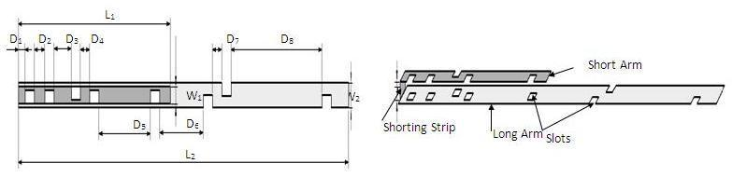

Fig. 1: Geometry of the new wideband antenna.

II. NUMERICAL & EXPERIMENTAL RESULTS OF THE NEW ANTENNA

Two versions of the new LTE antenna have been designed, manufactured and tested. Calculated & measured return losses will be presented in addition to the calculated gain, efficiency and radiation patterns. The first antenna version can cover a frequency band from 698 MHz up to 1.51 GHz and it will be referred to as “the low band antenna”. To cover the high band portion of the LTE spectrum, a second version of the antenna has been designed and manufactured by scaling and optimizing the geometry shown in Fig. 1.The antenna is operating all over the high frequency band 1.71-3.8 GHz and it will be referred to as “the high band antenna”. A reduced size version of these wide band antennas can be developed and customized for smaller LTE devices with decreased but still acceptable efficiencies. The reduced size versions of the low and high band antennas will be also demonstrated.

30th NATIONAL RADIO SCIENCE CONFERENCE
(NRSC 2013)
April 16‐18, 2013, National Telecommunication Institute, Egypt

A. The Low band and high band antennas

The low band antenna has a volume of 1.3x0.4 x14.5 = 7.54 cm³. It should be noted that the proposed volume is the total volume of the antenna because it does not require an additional ground plane or matching circuits. The high band antenna has a volume of 1.2x0.4 x5.9 = 2.832 cm³. Like the low band antenna, the proposed volume of the high band antenna is the total volume of the antenna. As Fig. 2(a) shows, the return loss of the low band antenna is lower than -8 dB over most of the band having a maximum value of -5.5 dB. For the high band antenna, Fig. 2(b) shows that the return loss is also lower than -8 dB all over the band. The total efficiency shown in Fig. 3

(a) and Fig. 3(b) demonstrates 80% and 90% average efficiencies of the low band and high band antennas, respectively. The gain of the low band antenna is shown in Fig. 4 (a) as a function of the frequency, while the high band antenna’s gain is shown in Fig. 4(b). The Radiation patterns of the low band antenna and high band antennas are demonstrated in Fig. 5(a) at 900 MHz and Fig. 5(b) at 2.7 GHz respectively, at phi = 0 & phi = 90.
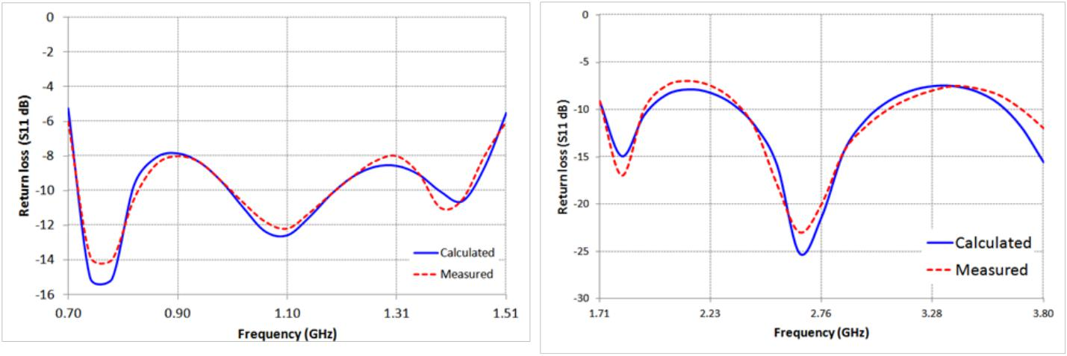

Fig. 2: Return loss (S11) of: (a) The low band antenna and (b) The high band antenna.
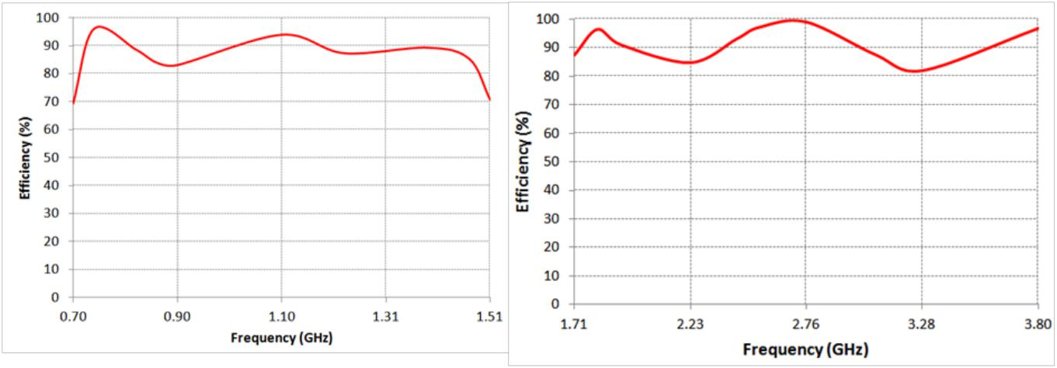

Fig. 3: Efficiency of: (a) The low band antenna and (b) The high band antenna.

30th NATIONAL RADIO SCIENCE CONFERENCE
(NRSC 2013)
April 16‐18, 2013, National Telecommunication Institute, Egypt
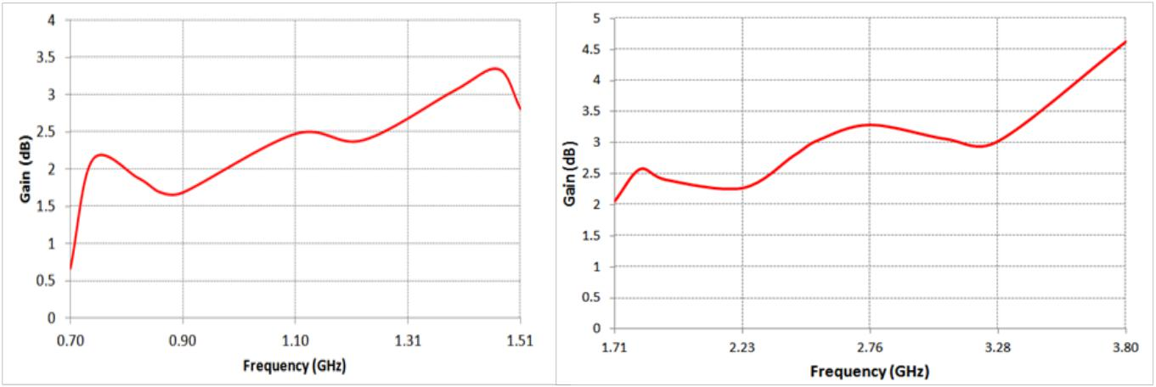

Fig. 4: Gain of: (a) The low band antenna and (b) The high band antenna.
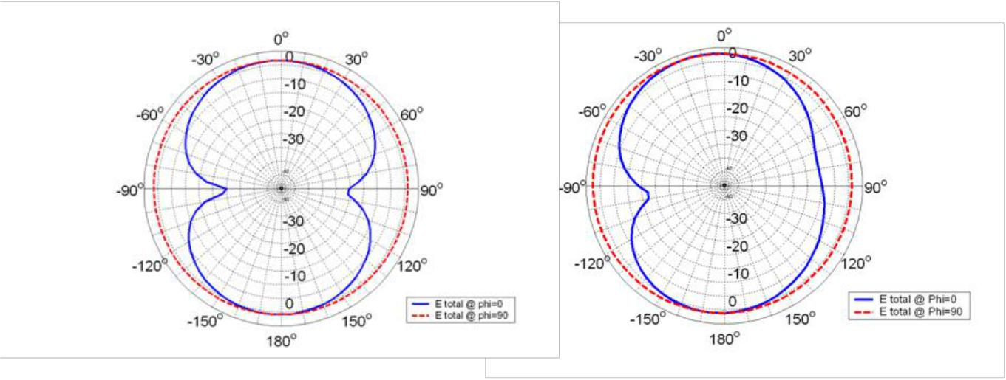

.

Fig. 5: Radiation Patterns of: (a) The low band antenna at 900 MHz and (b) The high band antenna at 2.7 GHz.

B. Reduced size version of the low band and high band antennas

The reduced size version of the low band antenna has a total volume of 0.4x0.4x15.6 = 2.496 cm³, while the high band antenna has a total volume of 1.2x0.4 x5.9 = 2.832 cm³. As Fig. 6(a) shows, the return loss of the low band antenna is lower than -5 dB almost all over the frequency band from 698 MHz to 1.51 GHz which is 73 % band width. For the reduced size version of the high band antenna, Fig. 6(b) shows that most of the calculated and measured return loss is lower than -5 dB all over the frequency band from 1.71 GHz to 3.8 GHz which is 75.8%. The total efficiencies shown in Fig. 7(a) and Fig. 7(b) demonstrate almost 70% and 80% average efficiencies of the reduced size versions of low band and high band antennas, respectively. The gain of the reduced size version of the low band antenna is higher than 1 dBi over most of the band as shown in Fig. 8(a), while the high band antenna’s gain is more than 2 dBi as shown in Fig. 8(b). The Radiation patterns of the low band and high band antennas are presented in Fig. 9(a) at 750 MHz and Fig. 9(b) at 2.7 GHz, respectively.

30th NATIONAL RADIO SCIENCE CONFERENCE
(NRSC 2013)
April 16‐18, 2013, National Telecommunication Institute, Egypt
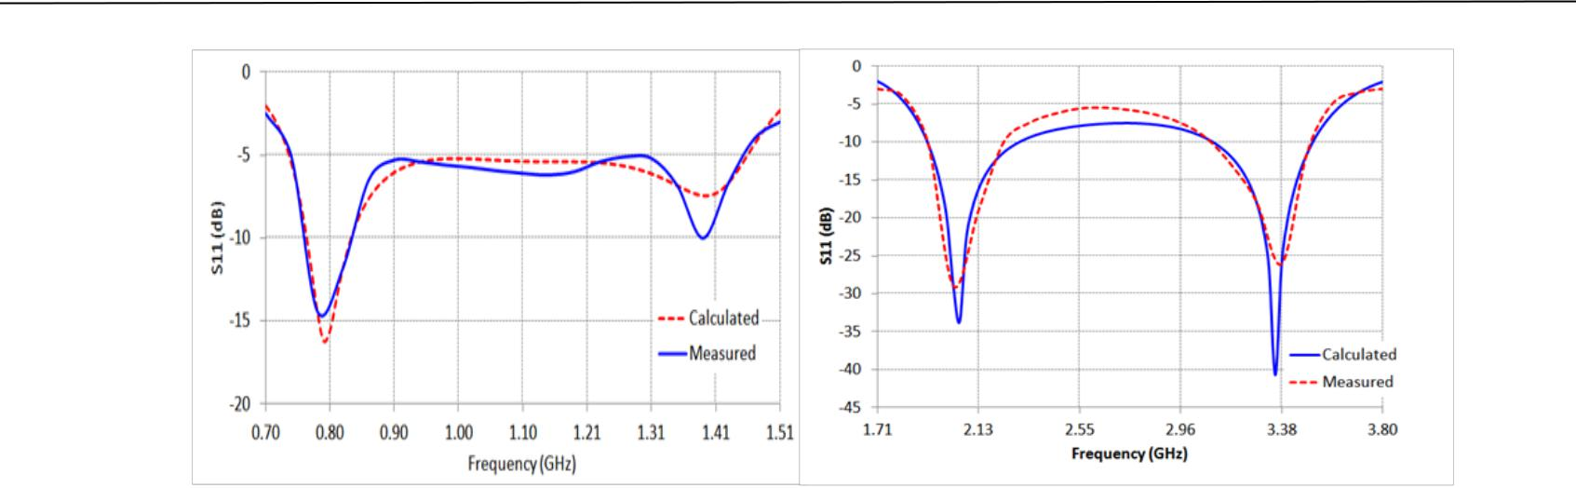

Fig. 6: Return loss of: (a) The reduced size version of the low band antenna and (b) The reduced size version of the high band antenna.
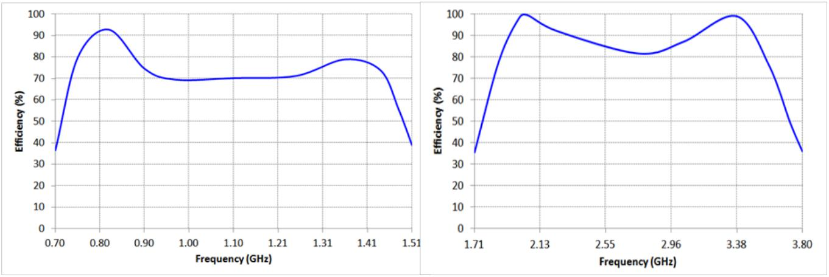

Fig. 7: Efficiency of: (a) The reduced size version of the low band antenna and (b) The reduced size version of the high band antenna.
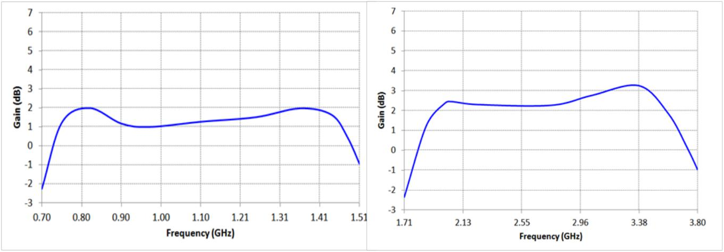

Fig. 8: Gain of: (a) The reduced size version of the low band antenna and (b) The reduced size version of the high band antenna.

30th NATIONAL RADIO SCIENCE CONFERENCE
(NRSC 2013)
April 16‐18, 2013, National Telecommunication Institute, Egypt
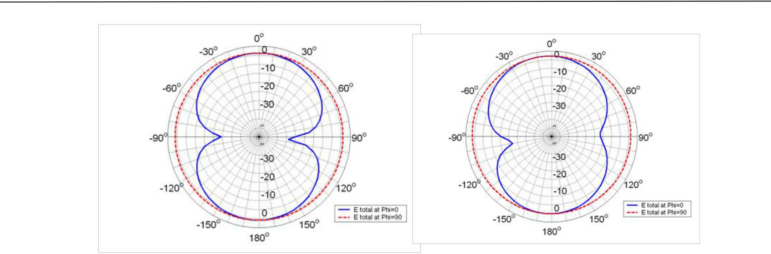

Fig. 9: Radiation Patterns of: (a) The reduced size version of the low band antenna at 750 MHz and (b) The reduced size version of the high band antenna at 2.7 MHz.

III. MIMO DIVERSITY CONFIGURATION

Multiples of low and high band antennas can be used for LTE MIMO diversity coverage in laptops, tablets and smart phones. Each of these different situations has been studied and will be presented.

A. MIMO configurations for smart phones

The new wide band antenna can be customized for implementation in smart phones. It can be bent or wrapped as an “L” shape to fit in the void around the chassis of the handset. This customization has been studied numerically and experimentally for 2x2 MIMO of the reduced size low band and high band antennas. As shown in the schematic in Fig. 10, the primary reduced size low band antenna is marked as number “1” and the diversity antenna is marked as number “2”. The primary and diversity antennas are wrapped in “L” shaped configurations. A 2x2 MIMO configuration of the reduced size high band antenna has been also tested numerically and experimentally and their relative positions to each other have been optimized for the implementation in smart phones. The relative positions of the primary and diversity antennas are shown in Fig. 10. The primary reduced size high band antenna is marked as number “3” and the diversity antenna is marked as number “4”.
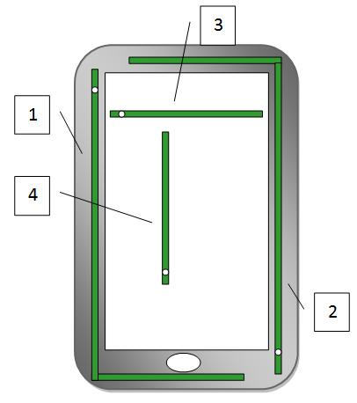

Fig. 10: The schematic diagram of MIMO wide band antenna solution for LTE smart phones.

30th NATIONAL RADIO SCIENCE CONFERENCE
(NRSC 2013)
April 16‐18, 2013, National Telecommunication Institute, Egypt

The measured isolation between the primary and diversity low band antennas has been investigated. As shown in Fig. 11(a), an acceptable isolation values, lower than -10 dB are obtained from isolation measurements (S21) in free space. The measured isolation on the chassis of smart phone was much better than the isolation in free space, as it has an average of -15 dB over most of the band. This is due to the fact that the phone is acting as an isolating medium which guarantees lower coupling between the primary and diversity antennas. The correlation coefficient between primary and diversity low band antennas was lower than 0.55 as shown in Fig. 11(b). On the other hand, the measured isolation between the primary and diversity high band antennas was lower than -30 dB as shown in Fig. 12(a).This is an expected isolation result due to the perpendicular position of the primary antenna relative to the diversity antenna which have been proved to be the best isolation technique in such a small available space inside handsets [9]. The perpendicular relative position also has a positive effect on the correlation coefficient. As shown in Fig. 12(b), the maximum correlation value does not exceed 0.1 and most of the values are lower than 0.01.
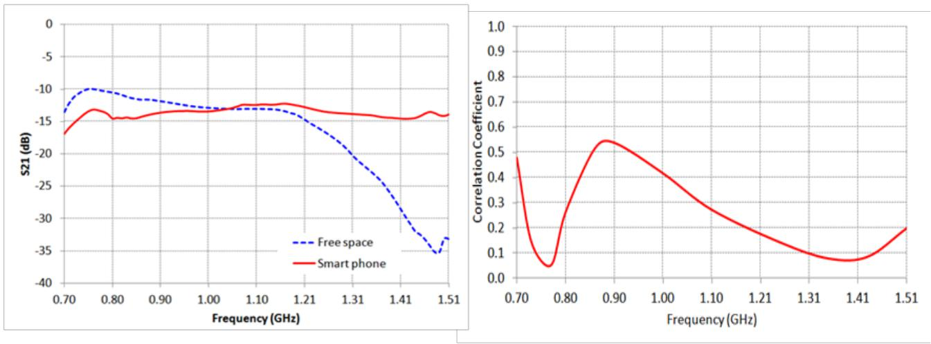

Fig. 11: (a) Measured isolation (S21) and (b) Correlation coefficient between primary and diversity MIMO low band antennas.
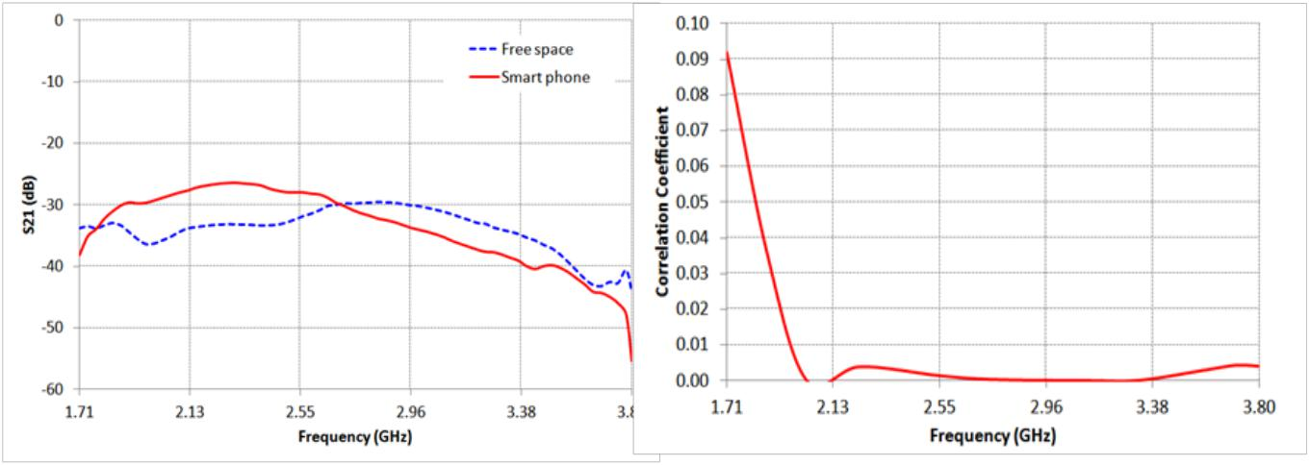

Fig. 12: (a) Measured isolation (S21) and (b) Correlation coefficient between primary and diversity MIMO high band antennas.

30th NATIONAL RADIO SCIENCE CONFERENCE
(NRSC 2013)
April 16‐18, 2013, National Telecommunication Institute, Egypt

The urgent demand for universal LTE smart phones requires an antenna solution that is able to cover most of the LTE bands for global roaming. By combining the two mew wide band antennas together in one device, it will fulfill that need as demonstrated in Fig. 10. The high band antennas marked as number 3 and 4 are located in a higher plane above the low band antennas by 1 mm .The biggest concern in this case is the isolation values between the low and high band antennas. The isolation is calculated for this case and the results are mostly lower than -20 dB for low band and high band frequency spectrums as shown in Fig. 13(a) and Fig 13(b) respectively.
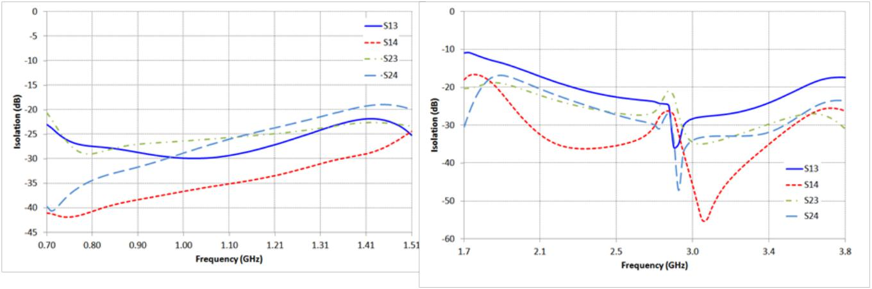

Fig. 13: Isolation between each low band and high band antennas in: (a) the low frequency band and (b) the high frequency band on smart phones.

B. MIMO configurations on laptops and tablets

For 2x2 MIMO diversity, a primary antenna and a diversity antenna can be placed 10 cm apart and perpendicular to each other inside laptops and tablets. Although primary and diversity antennas are operating over the same frequency band at the same time, the coupling effect is significantly reduced as a result of antennas perpendicular relative positions [8]. Thus, this position will have a positive effect on the calculated correlation coefficient between the two of the reduced size low band antennas, as shown in Fig. 14(a). The maximum correlation coefficient value is lower than 0.025. The isolation between the primary and the diversity antennas has been measured on a laptop and in free space keeping the same relative positions and distance between them. The measured isolation on the laptop gets improved over most of the band as demonstrated in Fig. 14(b). The previous experiments are repeated for 2x2 MIMO of the reduced size high band antennas perpendicular to each other and 10 cm apart. In terms of wavelength, the distance between the primary and the diversity antennas is larger in the high frequency band than in the low frequency band. This is reflected in a positive way on the correlation coefficient values which are lower than 0.001 as shown in Fig. 15(a). Also a lower isolation than -30 dB in free space and on the laptop is shown in Fig. 15(b).

30th NATIONAL RADIO SCIENCE CONFERENCE
(NRSC 2013)
April 16‐18, 2013, National Telecommunication Institute, Egypt
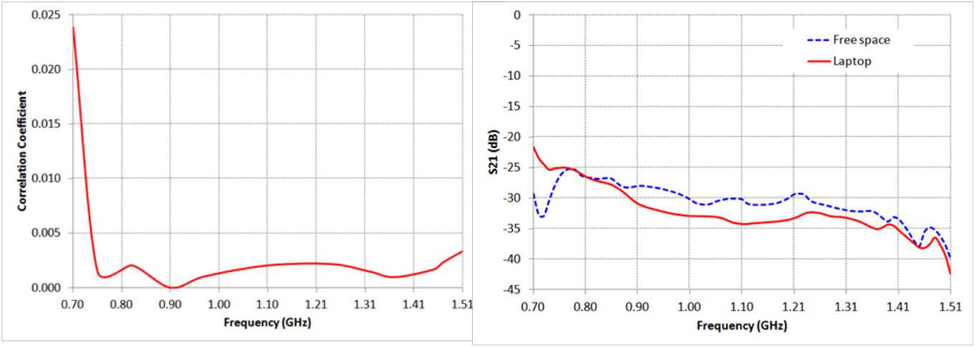

Fig. 14: (a) Correlation Coefficient and (b) Measured isolation between primary and diversity MIMO low band antennas perpendicular to each other and 10 cm apart.
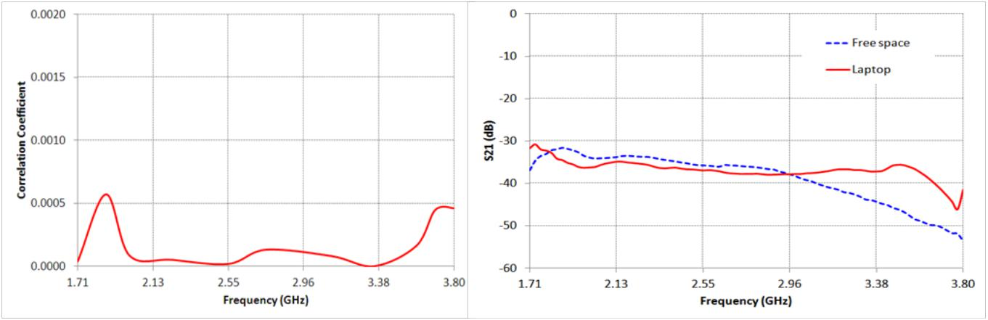

Fig. 15: (a) Correlation Coefficient and (b) Measured isolation between primary and diversity MIMO high band antennas perpendicular to each other and 10 cm apart.

IV. CONCLUSION

A novel very wide band MIMO antenna solution was developed, capable of covering more than 30 LTE bands besides 2G & 3G. This provided device manufacturers with a new antenna technology to fulfil the urgent need for universal LTE smart phones, tablet computers, laptops and notebooks.

ACKNOWLEDGMENT

The author would like to thank Lamiaa Nail and Mahetab Salama for their great effort in preparing this paper.

REFERENCES

[1] “LTE: the Future of Mobile Broadband Technology”, Verizon wireless.

30th NATIONAL RADIO SCIENCE CONFERENCE
(NRSC 2013)
April 16‐18, 2013, National Telecommunication Institute, Egypt

- (2012) the global telecommunications business website [Online] available at: http://www.globaltelecomsbusiness.com/Article/2948514/Sectors/25196/38-fragmented-frequencies-confuse-scale-benefits-of-LTE-terminals.html

- P. Vainikainen, J. Holopainen, C. Icheln, O. Kivekas, M. Kyro, M. Mustonen, S. Ranvier, R. Valkonen, and J. Villanen, “More than 20 antenna elements in future mobile phones, threat or opportunity?”, Antennas and
Propagation, 2009, EuCAP 2009. 3rd European Conference on 23-27 March 2009, pp. 2940-2943.

- Byoung-Nam Kim, Seong-Ook Park, Jung-Keun Oh, and Gwan-Young Koo, “Wideband Built-In Antenna with New Crossed C-Shaped Coupling Feed for Future Mobile Phone Application”, IEEE antennas and wireless propagation letters, vol. 9, pp. 572-575, 2010.

- (2012) mobile development & design website [online]. Available :http://mobiledevdesign.com/tutorials/4g-devices-demand-active-antenna-solutions-0216/?cid=ed

- M. Sanad and N. Hassan, “A 470 to 960 MHz resonant antenna: covering UHF mobile TV and CDMA/GSM without tuning circuits”, Microwave Journal, vol. 53, no. 11, pp. 56–73, 2010.

- M. Sanad and N. Hassan, “Dual antenna configuration for multi-standard multifunction handsets and portable computers,” in Proceedings of the 3rd European Wireless Technology Conference (EuWiT ’10), pp. 173–176, September 2010.

- M. Sanad and N. Hassan, "Low-Interference Dual Resonant Antenna Configurations for Multistandard Multifunction Handsets and Portable Computers", International Journal of Antennas and Propagation, March 2012.

